**Software Testing Assignment Module 1**

**Q-1** What is SDLC ?

**Ans** SDLC stands for Software Development Life Cycle. It’s a structure that defines the process of planning, implementation, testing, documentation, deployment & maintenance of software.

ISO/IEC 12207 standard is to establish a life cycle for software.

**Q-2** What is software testing ?

**Ans** It’s a process used to identify the correctness, completeness & quality of developed computer software. By testing we can identify any gaps, missing requirement & errors of software.

Static testing can be done without execution of code during verification process.

In Dynamic testing, we have to execute the code to run test during validation process.

Rules & regulations of software testing is maintain by ISTQB (International Software Testing Qualifications Board).

**Q-3** What is Agile methodology ?

**Ans** Agile methodology is software testing method which is a combination of iterative and incremental process models with focus on process adaptability and customer satisfaction.

Agile model believes that every project needs to be handled differently and the existing methods need to be tailored to best suit the project requirements.

**Q-4** What is SRS ?

**Ans** SRS stands for Software Requirements Specification. It’s a complete description of behavior of the system to be develop.

Customer requirement is related to client’s need & desires, like where the software is to be use and how long is to be used etc..

Functional requirement is for system design process. These are technical requirement & data manipulation etc..

Non-Functional requirement is for judge the operation of system. These are standards/qualities that system under dev must have.

Sub categories are below,

> Usability

> Reliability

> Performance & Security

**Q-5** What is OOPS ?

**Ans** OOPS stands for Object Oriented Programming. It’s a methodology to design a program using classes and objects. It simplifies software development & maintenance by making class & making objects interact.

**Q-6** Write basic concept of OOPS.

**Ans**

//Object > Any entity that has state & behavior is known as an Object. Also define as instance of class & contain address that take up some space in memory. Ex. Pen, Table, Bike etc..

//Class > Collection of objects is called class & it’s logical entity from which we can create individual object, abstract properties & behavior of object. Ex. 10th standard class etc..

//Encapsulation > Binding/wrapping code & data together into a single unit. Ex. Capsule etc..

//Abstraction > Hiding internal details & showing only essential information or functionality to outer side. Ex. Process of phone call(we don’t know internal process)

//Polymorphism > Having many forms & ability to use an operator or function in different ways. Ex. To reach destination with different ways.

Two methods in polymorphism given below,

> Overriding

(multiple methods have same name with same signature)

> Overloading

(multiple methods have same name with different signature)

//Inheritance > To inherits some feature from one class to other class. By using this we can reduce the size of codes.

Ex. Grandparent🡪Parent🡪Children

**Q-7** Draw usecase on online book shopping.

**Ans** 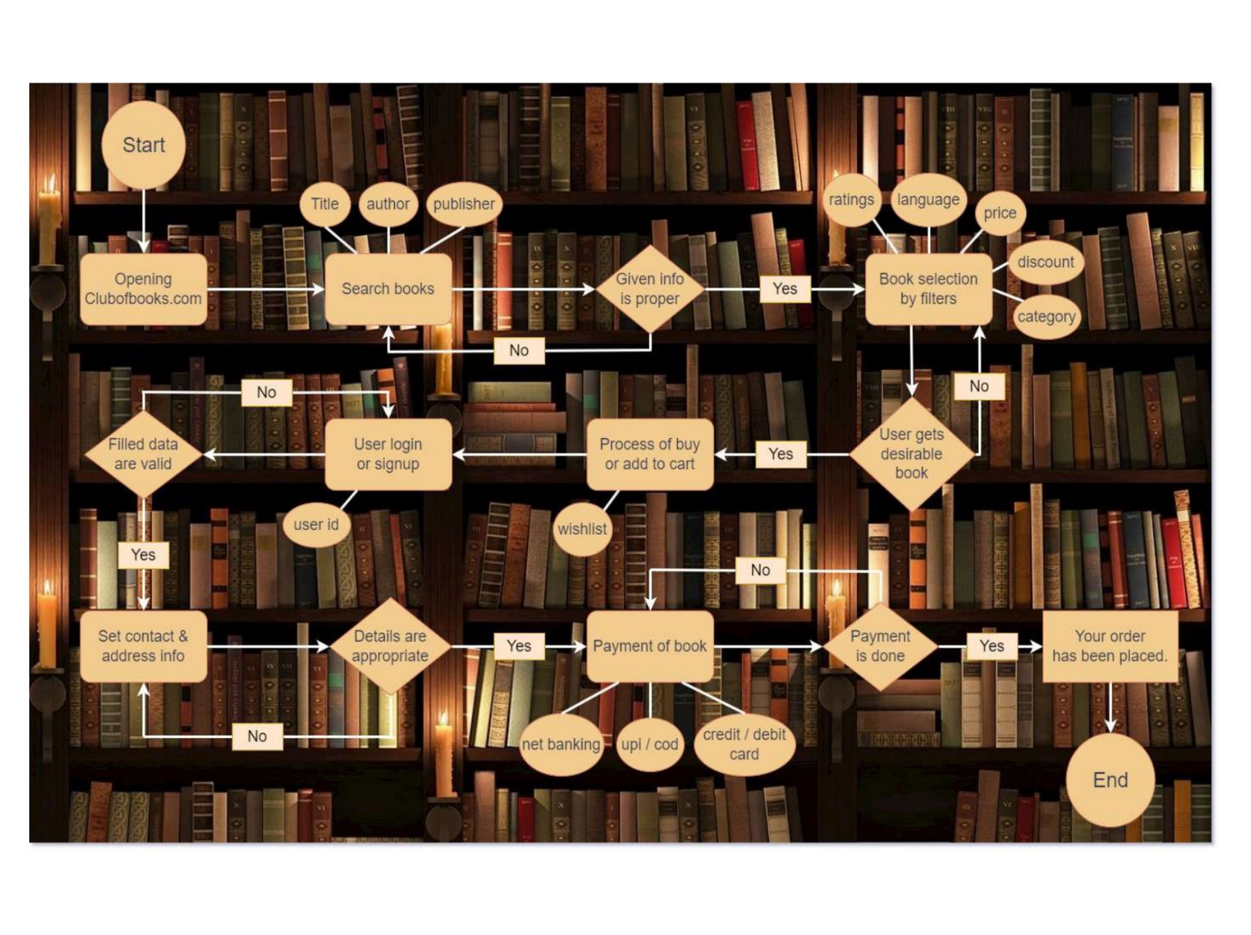

**Q-8** Draw usecase on online bill payment system.

**Ans** 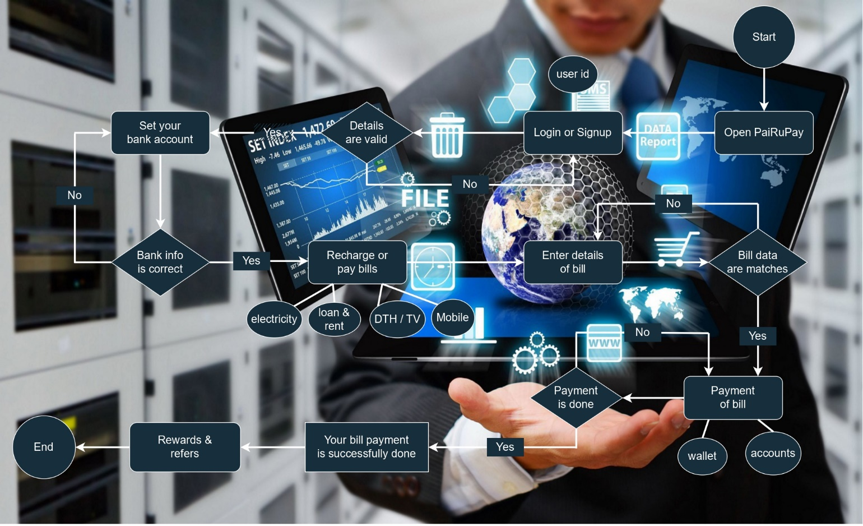

**Q-9** Write SDLC phases with basic intro.

**Ans**  Six phases of SDLC are given below,[1] Requirement gathering > collect client’s requirement like functional & non-functional by diagrams, tables & UML. Ex. Features, usage scenarios etc..

[2] Analysis phase > This phase states in clear & precise manner that what is to be built, by WHAT & HOW method. [3] Design phase > This phase is related to designing of software & contain design architecture docs, critical priority analysis etc..

[4] Implementation phase > This phase deals with issues of quality, performance, baseline, libraries & critical error removal

[5] Testing phase > In this phase we test the software through different test methods like unit testing, stress testing etc..

[6] Maintenance phase > To maintain the developed software. Types of maintenance are below,

> Corrective (identify & repair defects) Ex. Whatsapp bugs

> Adaptive (existing solution to new platform) Ex. Wapp web

> Perfective (implement new requirement) Ex. Wapp payment

**Q-10** Explain phases of waterfall model.

**Ans** Waterfall model also called classical software cycle. It’s rigid model & use for short term projects like 6 to 8 months.

Waterfall model is contain same phases as SDLC phases, so refer from previous answer for this question.

The only difference is that in waterfall model we can’t go in backward direction to process previous phases. So, client’s requirements & needs to be fixed early.

Sequence of phases are given below, Req.🡪Analysis🡪Design🡪Implement🡪Testing🡪Maintenance

**Q-11** Write phases of spiral model.

**Ans** Four phases of spiral model are given below, {1} Planning > In this phase we collect initial requirements of client & evaluate plan.

{2} Risk analysis > In this phase we do analysis of risk related to software & taking the decision to go or no go in next phases.

{3} Development > In this phase developers are evolving the software through coding.

{4} Customer evaluation > In this phase testing related to developed software is done & also, client can test their software through Alpha demo.

**Q-12** Explain Agile methodology with pros & cons.

**Ans** Agile model is a combination of iterative and incremental process models that break the product into small incremental builds.

Every iteration involves cross functional teams working simultaneously on various areas like planning, requirements analysis, design, coding, unit testing, and acceptance testing.

In agile the tasks are divided to time boxes (small time frames) to deliver specific features for a release. Iterative approach is taken & working software build is delivered after each iteration.

Pros :- > Rapid delivery of working software product > No deadline on project completion > Have flexibility & adaptability > Resource requirement is less

Cons :- > Growth of software depends on customer interaction > More risk of sustainability, maintenance & extensibility > Transfer of tech to new member is challenging

**Q-13** Draw usecase on online shopping product using COD

**Ans** 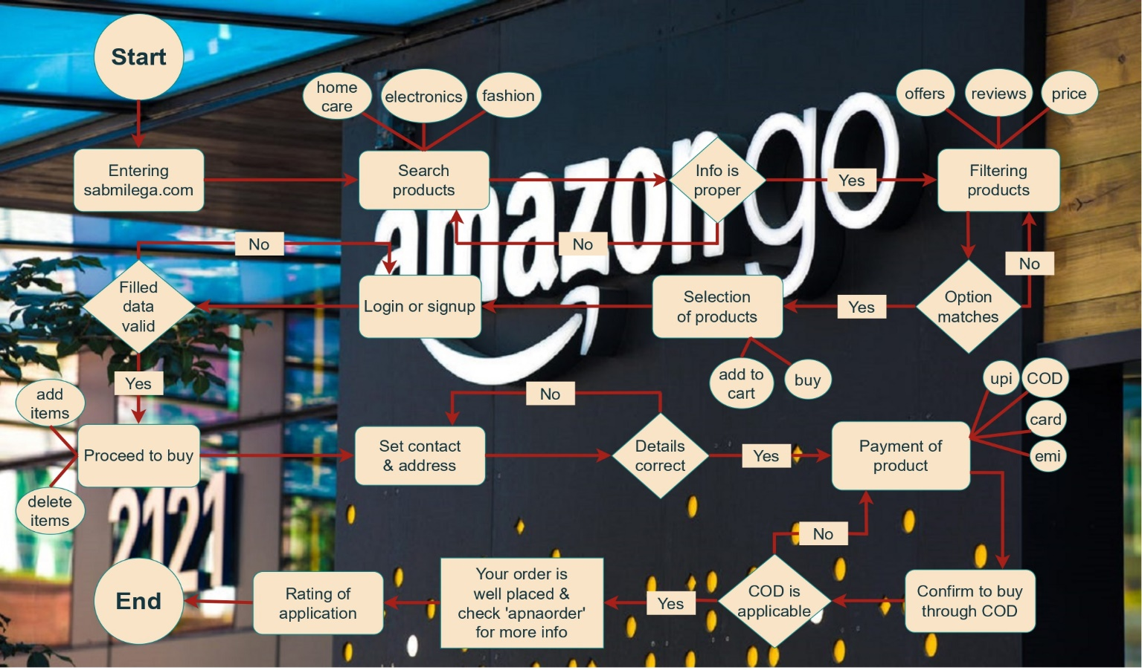

**Q-14** Usecase on online shop product using payment gateway

**Ans** 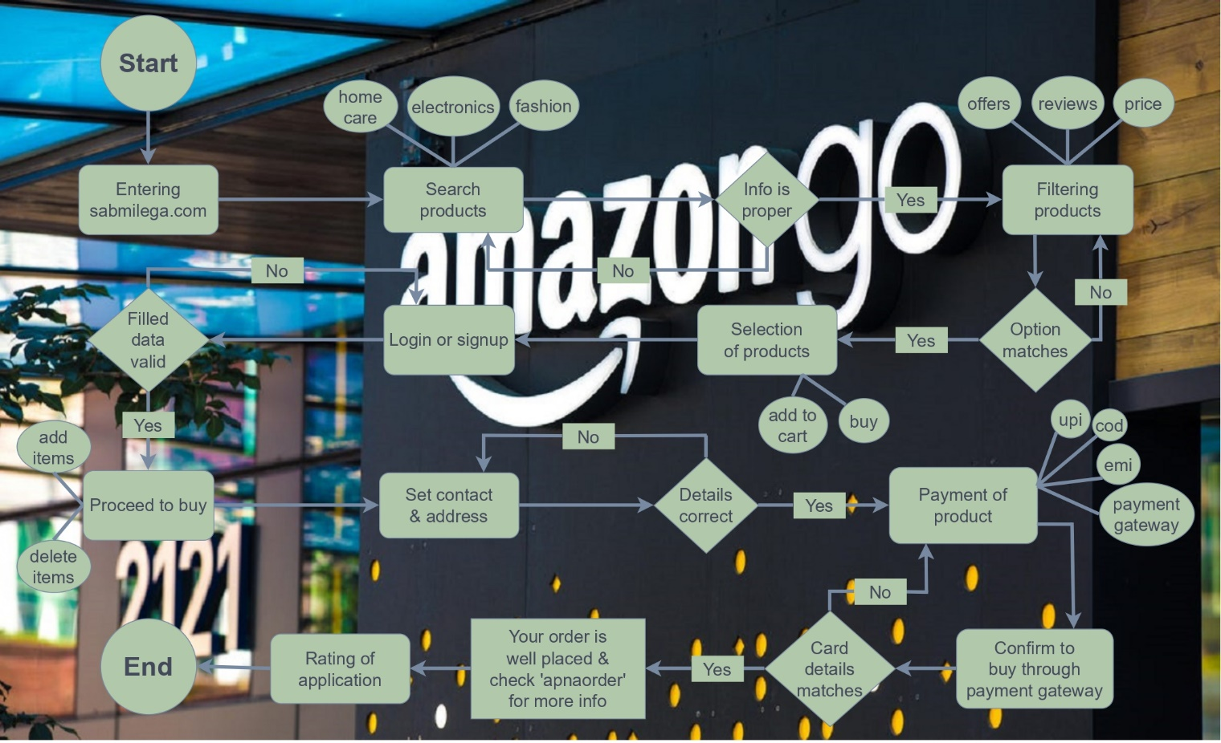

System.out.print(“THE END”);